**Practical 3: Chapter 5 Table**

**Section A:**

**Lab Exercise (Compulsory)**

Page : Practical 3PDF- 489 to 490 (Chapter 5 Table)

Exercise (s): Review Assignments (Tutorial 6)

Page : Practical 3PDF- 422 to 425 (Chapter 5 Table – different design for different device)

Exercise (s): Review Assignments (Tutorial 5)

**Additional Lab Exercise (Optional)**

Page : Practical 3 PDF- 491 to 492 (Chapter 5 Table)

Exercise (s): Case Problem 1 (Tutorial 6)

**Section B:**

Question 1

Use HTML code and embedded styles sheet to create the table in Figure 1 with the following specifications:

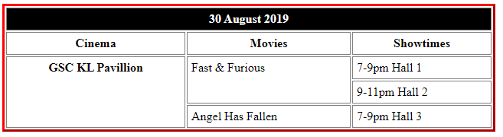

Figure 1

Specifications:

* The table takes up 50% of the display area. Create separate borders for table border and cell border.
* Set the table border to red color , 2-pixel width and solid border style.
* Set the cell border to grey colour, 1-pixel width and solid border style.
* Set the space between cell border and cell text to 5 pixels.
* Mark the first two rows and the first column of the table as the table heading cells.
* Insert inline styles into the first row, set the background colour to black and text colour to white.

Question 2

Use HTML and CSS code to create the table in Figure 2 with the following specifications

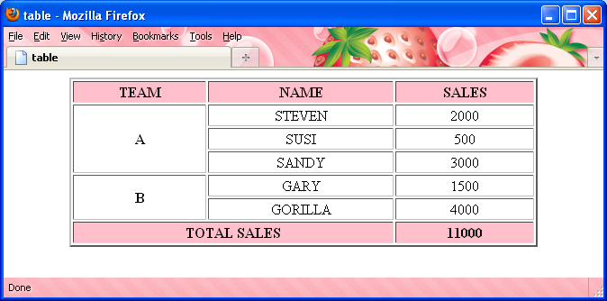

Figure 2

**Specifications:**

* Identify the <thead><tbody> and </tfoot> element.
* Centralized the text within the table.
* Set the table width to 80% of the window.
* Set the table border to 2 pixels.
* Make the first row and last row as table headings.
* Set the background colour of the first row and last row to pink colour.